Community Work Skills at a Grocery Store

Checking Expiry Dates

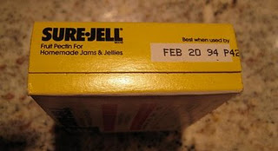

Expiry Date: is a date when something will end.

Some items you buy do not last forever.

Name some items you know.

______________________________________ ____________________________________

______________________________________ ____________________________________

______________________________________ ____________________________________

_____________________________________ ____________________________________

How do you know when something is expired and needs to be removed from the shelf?

- You need to know what today’s date is.

- You need to make the decision to take it off the shelf.

How Do You Make the Decision to Remove the Item From the Shelf ?

1. You need to understand the Dates

Dates are located on most every thing you buy. They can be found almost anywhere, on the top, bottom, and sides of the item you are buying.

Dates usually have a: month, a number for the day, and a year

They may look like this:

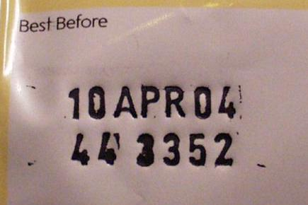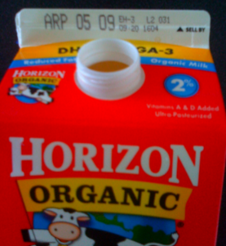

10 / APR / 04 or APR / 05 / 09
date month year month date year

Sometimes the date only has a month and date.

The date may look like this:

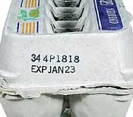

JAN 23
Month Year

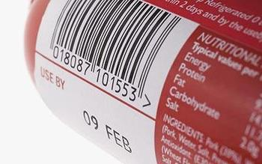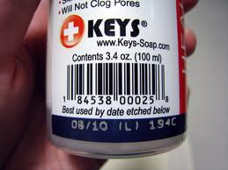
09 / FEB 08 / 10
Year Month Month Year

Once you understand the different dates you are ready to think about whether you will keep the item on the shelf.
Keeping Items on the Grocery Store Shelf

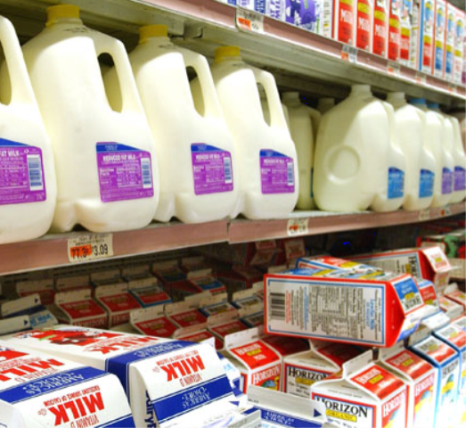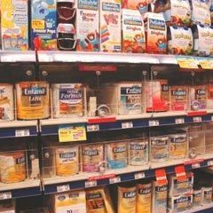

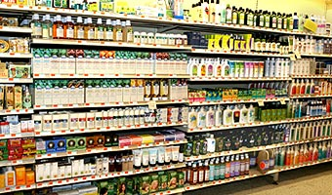

2. Making the decision to keep grocery items on the shelf

Steps to Follow:

- Write down today’s date

- Check the date on the item (remember dates aren’t written the same way all the time)

- The items’ date should be in the future (it hasn’t happened yet)

- If the date has not happened yet, keep it on the shelf.
Date:________________

Let’s try:

With the items on the table decide whether it should stay on the shelf or be removed.

Item | Today’s Date | Expiry Date | Stay | Remove

