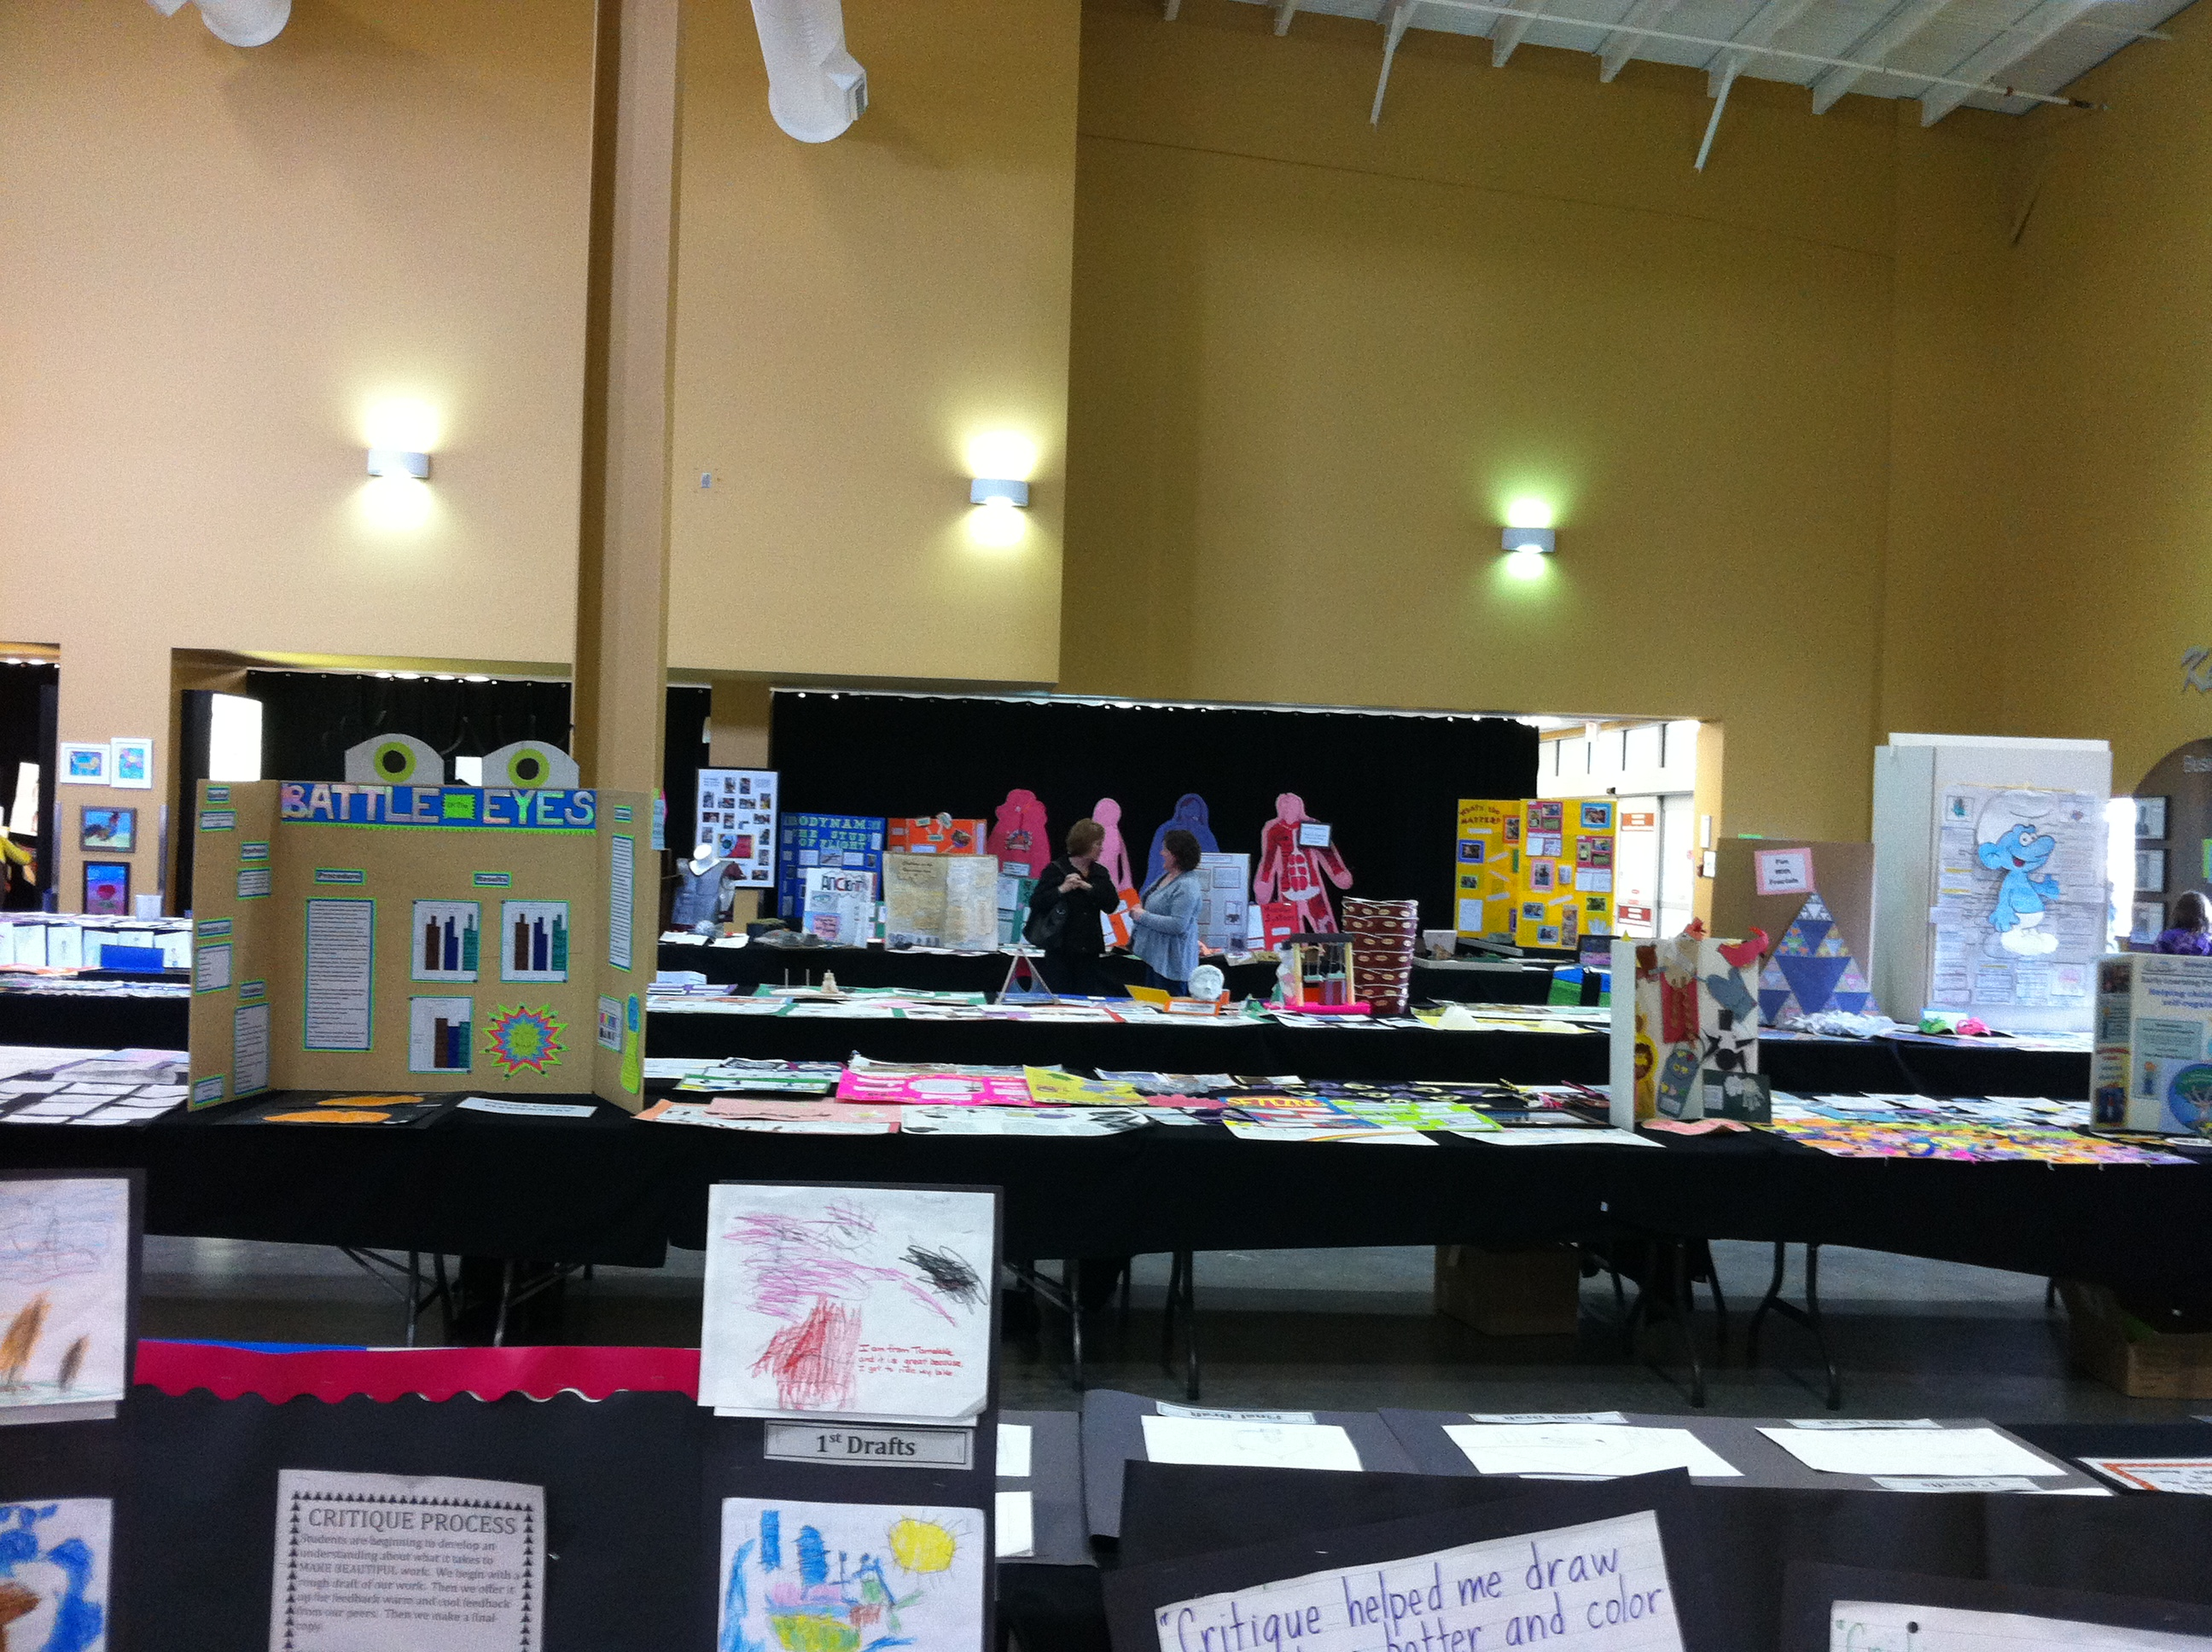
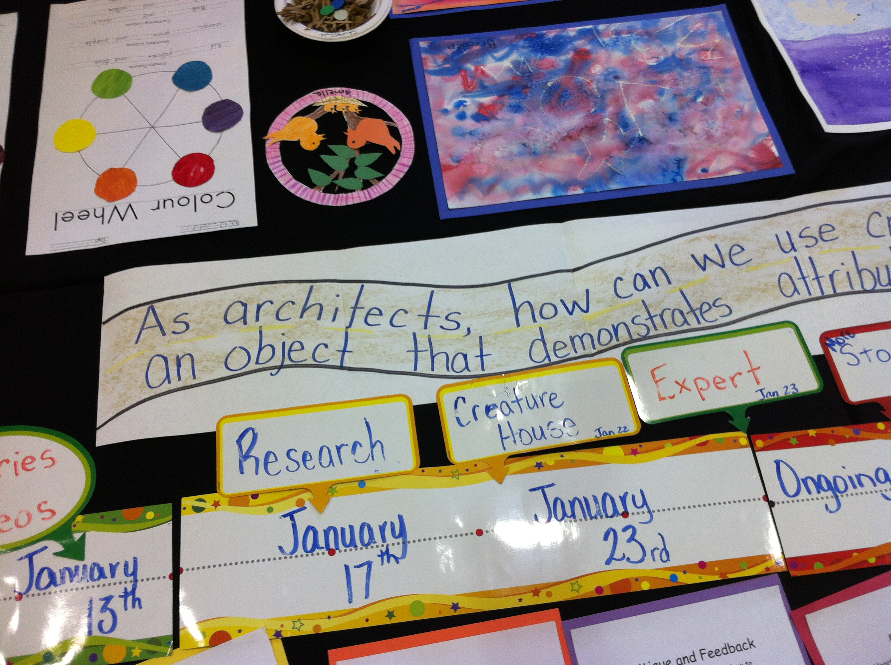
An exhibition of learning was held at the Encana Center on April 19, 2013 and it was a beautiful sight to see. Work samples of students from every school in School District 59, were displayed at the Beautiful Work fair. Twenty-first learning skills were evident in the displays in the form of multiple drafts, critiquing feedback, essential questions, group projects, posters of process and creative ideas. (ie. How Can Math Be Beautiful?) Technology was also presented in many formats, such as photography, movies, commercials, slideshows, power point presentations, and music. The Beautiful Work fair had three purposes. First, we wanted to showcase the students and their accomplishments. Second, we wanted to celebrate the work of our teachers, and provide a forum for sharing ideas. Finally, we wanted the community to feel connected to our students, staff and schools and the exhibition gave the public an opportunity to see the great things happening in the north with a focus upon 21st Century Learning Initiatives .

